

**05n/06d**

**Krabi and Phuket tour package**

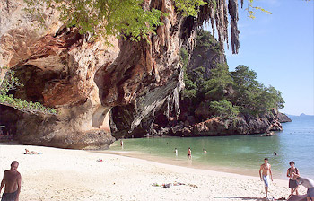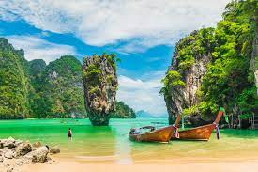

**Day 1 - Arrive in Krabi – Krabi city tour**

On your arrival at the Krabi International airport, meet our tour representative for assistance and transfer to one of our listed hotels. Check-in and relax in the comforts. The day is at your own leisure. Later proceed for Krabi city tour.

Overnight stay at Krabi.

**Day 02 – Krabi 04 island boat tour**

After breakfast proceed for Krabi 04 island tour which includes

1st Stop Pranang Beach. Secluded peninsular, inaccessible by car. Just a short walk away is a Princess Cave with decorative spirit house. Free time for sun-bathing, swimming, photography, exploring.

2nd Stop Tup Island. Exotic tropical island, ideal for easy snorkelling and exploring on foot. If the tide is low, you can walk along the white, sandy causeway joining the neighbouring island.

3rd Stop Chicken Island. Natural landmark, named after the shape of its unique limestone rock jutting out into the sea. Excellent snorkelling opportunities in warm, inviting waters, rich in coral life.

4th Stop Poda Island. Stunning jewel of the Andaman Sea with both lowland, picturesque bamboo plantation and majestic, rocky cliffs, bordered by long, beautiful beach. Lunch at the beach and break.

Overnight stay at Krabi

**Day 03 – Krabi - Phuket**

After breakfast proceed to Phuket by road and transfer to one of our listed hotels. Check-in and relax in the comforts. The day is at your own leisure. Phuket is one of the most happening holiday destinations in Thailand, known for beautiful beaches, thriving nightlife, exciting things to do, and places to see.

Overnight stay at Phuket

**Day 4 - Phuket – Phi Phi Island with Lunch**

Begin the day with breakfast at hotel. Later, get ready to explore the Phi Phi Island. Known as one of the most enchanting islands of Thailand, you will get there in 2 hours using a ferry. Enjoy the spectacular view of Maya Bay landscapes. The beauty of the island has been immortalized by the popular film 'The Beach' and you too can enjoy the bliss of the azure island like the movie. Lunch is organized at the beach-side hotels. Later, you will be taken to a secluded portion of the beach, where you try a hand at water sports activities like swimming, snorkeling, etc.

After a well-spent day return to the Phuket hotel.

Overnight stay at Phuket

**Day 5 – James bond Island tour with Lunch**

Begin the day with breakfast at hotel. Later, get ready to explore the James bond Island.

James Bond Island or locally known as Khao Phing Kan is the name given to a pair of islands situated on the West Coast of Thailand. Located in the Phang Nga Bay of Andaman Sea and about 40 meters away from the shore is another islet named Ko Tapu or Khao Tapu. The massive nail-like rock structure rising from between the water is a limestone cliff.

After a well-spent day return to the Phuket hotel.

Overnight stay at Phuket

**Day 6 - Phuket – Departure**

Start the day with a hearty breakfast at hotel. Later, pack your bags and check out of the hotel. Take the timely transfer to airport to board the return flight.