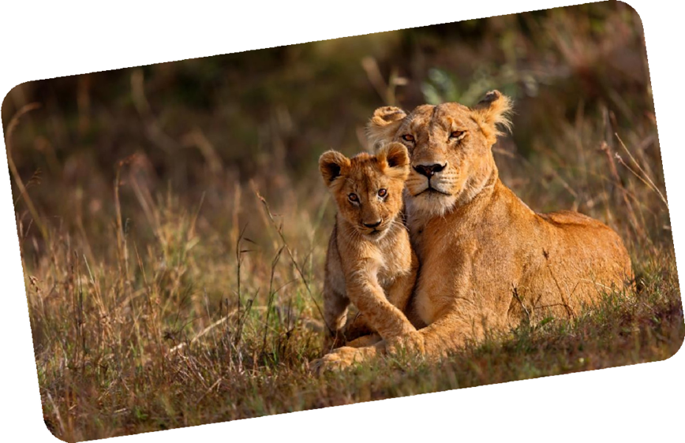

|  |  |
| --- | --- |
| **Day** | **Itinerary** |
| DAY 1 | Transfer JNB airport/Hotel - Private |
|  | at your leisure enjoy Emperors Palace Complex |
|  | Meal at an Indian restaurant (includes set menu / excludes drinks & any extras) **clients can walk - no vehicle or guide costed** |
|  | **Overnight at the Mondior Concorde (B&B) – 4 Star** |
| DAY 2 | Breakfast at your hotel |
|  | Private Full Day: Visit the Lion & Safari Park incl. 1 hour predator tour |
|  | Meal at a Local restaurant (includes set menu / excludes drinks & any extras) |
|  | Meal at an Indian restaurant (includes set menu / excludes drinks & any extras) **clients can walk - no vehicle or guide costed** |
|  | **Overnight at the Mondior Concorde (B&B) – 4 Star** |
| DAY 3 | Breakfast at your hotel |
|  | Private Transfer to Kruger View Chalets - approx 4½-5 hours |
|  | Local at Harry's pancakes in Dullstroom (excl. drinks) |
|  | Local at the Hotel (Excl. drinks) |
|  | **Overnight at Kruger View Chalets – 3 Star** |
| DAY 4 | Breakfast at your hotel |
|  | Full day game drive in the Kruger - 11-12 hours |
|  | Local at one of the rest camps inside Kruger (excl. drinks) |
|  | Local at the Hotel (excl. drinks) |
|  | **Overnight at Kruger View Chalets (Using a caterer)– 3 Star** |
| DAY 5 | 2 Hour morning game drive in the Kruger & Breakfast at the Hotel |
|  | Private Transfer Kruger View Chalets/JNB airport - approx 4½-5 hours |
|  | Packed local lunch en-route - small simple pack |
|  | ***Fly JNB/GRJ - flight*** |
|  | Private transfer GRJ airport/Knysna - approx 1 hour |
|  | Meal at an Indian restaurant (includes set menu / excludes drinks & any extras) |
|  | **Overnight at the Knysna Rex (B&B) 4 x Star** |
|  | Breakfast at your hotel |
|  |  |
| DAY 6 |  |
|  | Private Transfer to Oudtshoorn - approx 45 minutes |
|  | Visit the Cango Caves |
|  | Visit the Safari ostrich Showfarm incl. Indian lunch |
|  | Visit the Wildlife Ranch |
|  | Private Transfer Back to George - approx 45 minutes |
|  | Meal at an Indian restaurant (includes set menu / excludes drinks & any extras) |
|  | **Overnight at the Knysna Rex (B&B) 4 x Star** |
| DAY 7 | Breakfast at your hotel |
|  | Private transfer George/CPT - approx 5-6 hours |
|  | Local en-route |
|  | Meal at an Indian restaurant (includes set menu / excludes drinks & any extras) |
|  | **Overnight at the Southern Sun Cape Sun (B&B) – 4 Star** |
| DAY 8 | Breakfast at your hotel |
|  | Private Full day Cape Town City tour incl. Kirstenbosch Botanical Gardens. |
|  | Table Mountain (INCLUDES CABLEWAY TICKET - weather permitting) |
|  | A scenic coastal drive through Clifton and Sea Point. A scenic drive passing the Houses of Parliament, City Hall, Castle and Slave Lodge. See Green  Market Square, A walk through Company Gardens. Also The Bo-Kaap, traditional Malay Quarter. |
|  | Meal at an Indian restaurant (includes set menu / excludes drinks & any extras) |
|  | Meal at an Indian restaurant (includes set menu / excludes drinks & any extras) |
|  | **Overnight at the Southern Sun Cape Sun (B&B) – 4 Star** |
| DAY 9 | Breakfast at your hotel |
|  | Private Full day Cape Peninsula Tour incl. |
|  | View of Clifton Beach & Camps Bay. Drive to Simonstown via Chapmans Peak Drive (if open). Visit Hout Bay (seal island cruise - cost incl.) Visit Boulders beach penguin colony (entrance fee included). Go to Cape Point  Nature Reserve and visit the Cape of Good Hope (incl. funicular tram ride) |
|  | Meal at an Fishhoek Galley (includes set menu / excludes drinks & any extras) |
|  | Meal at an Indian restaurant (includes set menu / excludes drinks & any extras) |
|  | **Overnight at the Southern Sun Cape Sun (B&B) – 4 Star** |
| DAY 10 | Breakfast at your hotel |
|  | Transfer Hotel/CPT airport - Private |