

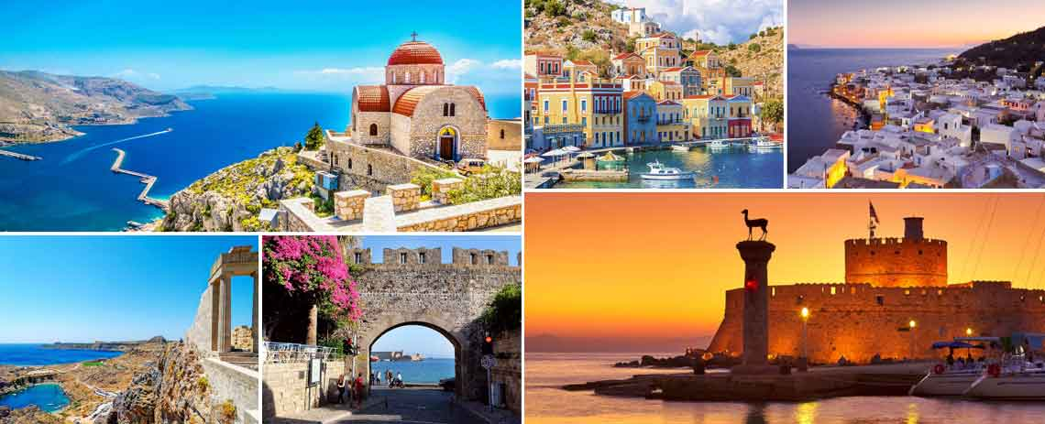

**TURKEY - GREECE EXPLORER**

**(09Days /08Nights)**

**DAY 01: ARRIVAL ISTANBUL – FREE & EASY – OVERNIGHT STAY**

Afternoon on arrival at Istanbul airport meet and assistance by our Tour guide and transfer to the Istanbul hotel in Taksim area. Later you are free to relax at the hotel . Overnight stay at the hotel .

Dinner at Outside Turkish Restaurant

**DAY 02: ISTANBUL – FULL DAY SIGHTSEEING – OVERNIGHT STAY**

Morning after breakfast proceed for a full day tour: Visit Dolmabahce Palace .After lunch drive to Ortakoy Quarter , Old Greek Town – Free time for shopping & photography / Later Visit Suleimaniye Mosque & Spice Market – Back to hotel In the evening transfer for evening dinner cruise with Show and unlimited local drinks / or / Turkish Night club with Show and unlimited local drinks ( depending on weather condition on October / November ) Back to hotel & Overnight Stay

**DAY 03: ISTANBUL – CAPPADOCIA – OVERNIGHT STAY**

After early breakfast Transfer to the airport after breakfast - Flight to Kayseri - Greeted by the guide at the airport - Transfer and full day regional tour : Özkonak underground city – Lunch at outside local restaurant ( 1 bottle of small water inc )- Güvercinlik valley Transfer to hotel & Check in - Dinner at Hotel

**DAY 04: CAPPADOCIA – FULL DAY SIGHTSEEING – OVERNIGHT STAY**

Morning after breakfast departure for a full day tour: Avanos & Pottery workshop ateliers Sinassos (Old Greek Town) Visit Constantine & Helen Church Lunch at outside restaurant. Visit Uchisar Town & Castle (photography break for Castle) Back to hotel – Dinner at hotel

**DAY 05: CAPPADOCIA – ISTANBUL – ATHENS**

Early morning optional Hot air balloon tour. After breakfast depending on flight time transfer to Cappadocia Airport to board flight to Athens Via, Istanbul. On arrival at Athens meet in the arrivals’ hall at Athens airport and transfer to the Hotel. Later proceed to visit The Parthenon a former  temple  on the [Athenian Acropolis](https://en.wikipedia.org/wiki/Acropolis_of_Athens), Greece, that was dedicated to the [goddess](https://en.wikipedia.org/wiki/Greek_gods) [Athena](https://en.wikipedia.org/wiki/Athena) during the fifth century BC. Its decorative sculptures are considered some of the high points of classical [Greek art](https://en.wikipedia.org/wiki/Art_in_Ancient_Greece), an enduring symbol of [Ancient Greece](https://en.wikipedia.org/wiki/Ancient_Greece), [democracy](https://en.wikipedia.org/wiki/Democracy) and [Western civilization](https://en.wikipedia.org/wiki/Western_culture). Dinner at Indian Restaurant and Overnight stay

**DAY 06: ATHENS – SANTORINI**

Morning after Breakfast, pick up at 06:00 and transfer to Piraeus port to board the ferry at 07:00 arriving Santorini at 11:40 Hrs . Later you will be transferred to the local restaurant to have lunch and then check in at the hotel. In the evening around 18:00 hrs pick up proceed for walking tour along with English speaking guide. Dinner at restaurant. Overnight stay

**DAY 07: SANTORINI – ISLAND TOUR – OVERNIGHT STAY**

Morning after breakfast you are free to relax at the hotel. Afternoon pick up from hote; and proceed for lunch at Indian restaurant . After lunch proceed for Island Tour , Wine Tasting tour , Prygos Village , Red Beach (from above) , Megalochori . Procced for Oia Village walking guided city tour . Dinner at Indian restaurant . Overnight stay at hotel

**DAY 08: SANTORINI – ATHENS**

Breakfast at the hotel. later check out from the hotel and proceed to board the ferry at 12:00 arriving Athens at 16:50 hrs . lunch will be provided on board. On arrival transfer to hotel for check in . Later pick up from hotel and transfer to Plaka. Dinner at local tavern with Greek music and folk dances. (Greek set menu)

Overnight stay at Hotel

**DAY 09: ATHENS – DEPARTURE**

Morning after breakfast free to relax at the hotel, Later according to the flight timings transfer to Athens airport to board the return flight with the sweet memories of a wonderful holiday