.



**NEPAL PACKAGE**

**04N/05D**

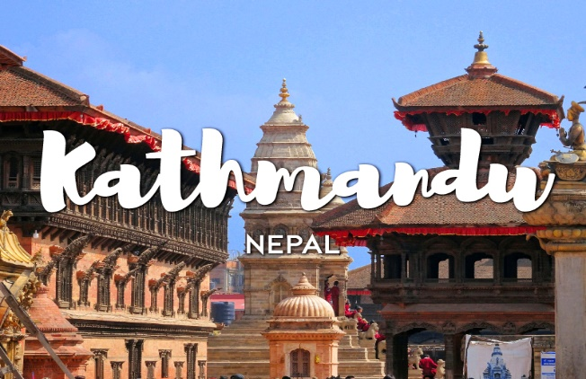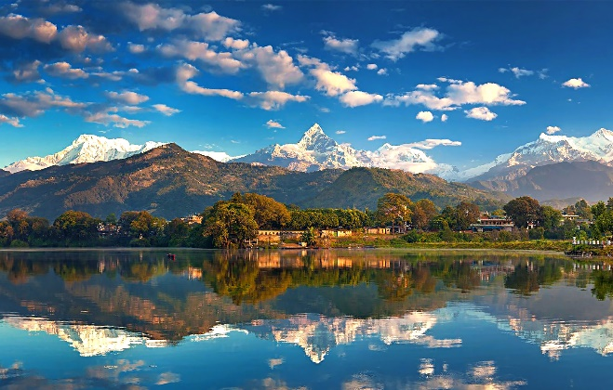

**Tentative itinerary: -**

**Day 01 - Kathmandu**

Meeting at airport upon arrival by Office Personnel. Transfer to hotel. Kathmandu is the capital of Nepal and the Kathmandu Valley is the political and cultural heart of the Kingdom.

The urban sprawl that makes up modern Kathmandu is in fact two cities, Patan and Kathmandu.

After short relaxation at the hotel, visit one of the Hindu cultures in Nepal, **Pashupatinath.**  This is the place where holy saddhus pray. The **Pashupatinath Temple** is a famous, sacred Hindu temple dedicated to Pashupatinath and is located on the banks of the Bagmati River 5 kilometres north-east of Kathmandu Valley in the eastern city of Kathmandu the capital of Nepal. This temple is considered one of the sacred temples of Hindu faith. The temple serves as the seat of the national deity, Lord **Pashupatinath**. This temple complex is on UNESCO World Heritage Sites's list Since 1979. This "extensive Hindu temple precinct" is a "sprawling collection of temples, ashrams, images and inscriptions raised over the centuries along the banks of the sacred Bagmati river".

**(The above sightseeing is for a maximum of 03 hours after the vehicle reports at the hotel )**

**Day 02 – Kathmandu / Pokhara ( By Flight )**

Fly to Pokhara. Pokhara is 30 mins approx by flight from Kathmandu. From Pokhara town (2,352 feet) in good weather there are splendid views right from the hotel.

**Day 03 – Pokhara**

This morning you will go for a excursion trip to **Sarangkot**. Sarangkot is the most popular tourist destination from where the tourists can enjoy the great view of the Pokhara Valley and the magnificent view of the Himalayas. Sarangkot is only 13 kms from Lake Side, Pokhara. It is the highest view point for a sunrise at an altitude of 1592mtsh. It is cooler than Pokhara. Ccan be reached easily within

45 to 60 minutes by a vehiclefrom Pokhara. Many tourists come to Sarangkot for sunrise.

From Sarangkot, on the northern direction we can see Dhaulagiri in the far west. Annapurna range is visible when the weather is clear on the same side. On the southern direction the village overlooks the city of Pokhara and its lake on the north-western outskirts of the city.

(The above sightseeing is for a maximum of 03 hours after the vehicle reports at the hotel)

This afternoon you will visit **Bindebasini Temple**. This is one of the oldest temples in Pokhara was a part of Kaski Kingdom, the main deity of the temple,Goddess Durga, was brought from India . Apart from the peace and tranquility that can be felt in this region, the premises of the temple offers a good view of the Himalaya on a clear day. The temple is in the area of the bazaar, hence,a journey of the old bazaar can be combined with a visit to the temple. Sightseeing to **Devi’s fall**, also known as Patale Chango is an awesome waterfall lying 2 km southwest of Pokhara. During summer and rainy season, the waterfall takes its real form, with gushing water splashing and making its way through the rocks. Just opposite of Devi’s fall, on the other side of the road, there is **Gupteshwor Cave**. This cave is popular for the different natural forms made from limestone deposits. Photography is strictly prohibited inside the cave. Overnight at hotel.

(The above sightseeing is for a maximum of 03 hours after the vehicle reports at the hotel)

**Day 04 – Pokhara / Kathmandu**

Fly back to Kathmandu & transfer to hotel. Rest day at leisure.

One can indulge in shopping or visit the casinos trying their lady luck on your own. Overnight at hotel.

**Day 05 – Kathmandu / Airport**

This morning your tour will take you for a visit to **Patan.**Also known as **Lalitpur**, the city of beauty is separated from Kathmandu only by the Bagmati River and is the second largest town in the valley. Lalitpur is fragmented from other cities due to its substantive architectural ancient masterpieces. Patan's central Durbar Square is absolutely packed with temples: Its an architectural center point with a far greater concentration of temples per sq. meter than in Kathamandu or Bhaktapur. Within the city also lies the Tibetan refugee center, home to most of the valley's Tibetan population.  While technically refugees, the Tibetans are some of the wealthiest people in the valley because of the carpet industry they operate.  For those looking to bring home a fine Tibetan carpet, this is the place to shop. You will then go to **Swayambhunath**the golden spire of the 5th-century Swayambhu stupa is adorned with a colorful fluttering of prayer flags; it crowns a hill overlooking the Kathmandu Valley and offers fantastic views over the city of Kathmandu. Swayambhunath is one of the most recognizable symbols in Nepal and the painted eyes of Buddha watch all who ascend the worn stone steps.

**(The above sightseeing is for a maximum of 03 hours after the vehicle reports at the hotel)**

Later, you will be transferred to the airport in time to board your flight for onward journey.