|  |
| --- |
| **Kolkata 2 Nights/Shillong 3 Nights /**  **Guwahati 1 Night** |

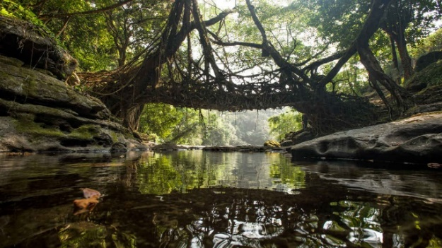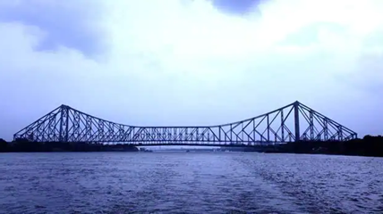

|  |
| --- |
| **Itinerary: -**  **1st Day - (Monday 1st May): Kolkata Airport to Hotel - Pickup & Kolkata Full Day City Tour (Vehicle: Pickup TO till 07:00 PM)**  Meet & greet on arrival at Airport & transfer to hotel. Check-in to hotel after that Kolkata full day Mother House, Birla Temple, Kalighat Temple, Netaji Bhavan, Indian Museum, Overnight stay at Kolkata. (*Drive Pass) |
|  |
| **2nd Day - (Tuesday 2nd May): Kolkata – Full day City Tour (Vehicle: 09:00 AM TO 07:00 PM)**  After breakfast start for full day Kolkata city tour. Howrah Bridge*, Belur Math, Vivekananda Setu*, Dakshineswar Temple, Botanical Garden. Overnight stay at Kolkata. (*Drive Pass)  **3rd Day - (Wednesday 3rd May): Kolkata to Kolkata Railway Station – Drop - Guwahati Airport to Shillong - Transfer**  Approx Distance: 30 Km • Est. Travel Time: 1 hour  After breakfast check out from hotel and transfer to the Airport for your onwards journey. arrival at Guwahati Airport & transfer to Shillong, which is also called the 'Scotland of the East". On the way visit the majestic Umium Lake (Barapani). You may do the water sports here (Optional). On arrival at Shillong, check in at your hotel. Evening you can visit Police Bazaar which is the biggest local market. Overnight stay at Shillong.  **4th Day - (Thursday 4th May): Shillong to Cherrapunjee - Excursion**  Approx Distance: 60 Km • Est. Travel Time: 2 hours  After early breakfast drive to Cherrapunjee (4,400 ft.), the wettest place in the world. You will see the beautiful waterfall known as Nohkalikai. You can also explore the caves known as Mawsmai. Evening return to Shillong, enroute visit Elephanta falls. Overnight stay at Shillong.  **5th Day - (Friday 5th May): Shillong to Mawlynnong and Dawki - Excursion**  Approx Distance: 120 Km • Est. Travel Time: 4 hours  After early breakfast drive to Mawlynnong – “Asia’s Cleanest Village”. Mawlynnong offers many interesting sights such as the living root bridge and another strange natural phenomenon of a boulder balancing on another small rock. Later proceed to Dawki, a small town near India Bangladesh border. Enjoy breathtaking view of the Umangot River. Evening drive back to Shillong. Stay overnight at your hotel in Shillong.    **6th Day - (Saturday 6th May): Shillong to Guwahati - Sightseeing and Transfer Sightseeing (Guwahati Sightseeing Depends upon time permit)**  Approx Distance: 100 Km • Est. Travel Time: 3 hours  After breakfast check out from hotel and visit Don Bosco Museum (Sunday Closed) & Ward’s Lake. After that drive to Guwahati. After that Guwahati Sightseeing visit Assam State Museum (Closed on Monday), State Zoo cum Botanical Garden, Regional Science Centre and Sukreswar Temple (The 6th Jyotirlinga of Shiva) and check in at your hotel. Overnight stay at Guwahati.    **7th Day - (Sunday 7th May): Guwahati Hotel to Guwahati Airport - Sightseeing and Transfer**  After breakfast check out from hotel, proceed to visit Kamakhya Temple (Notes -Timing 08:00 A.M till 01:00 P.M & 3:00 P.M till its gets dark), Tirupati Balaji Temple, Nabagraha Temple. Later drop at Guwahati Airport for onwards Journey. |
|  |

|  |
| --- |
|  |