

**HYDERABAD PACAKGE**

**03 NIGHTS /04 DAYs**

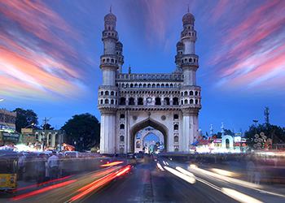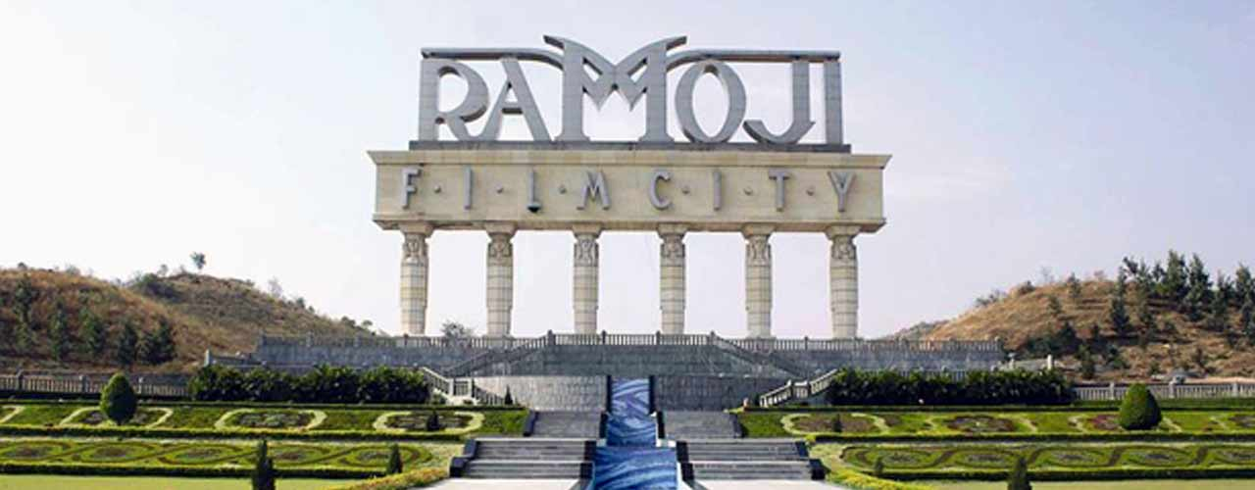

**Day 01: Trivandrum - Arrival Hyderabad**

Arrive at Trivandrum airport to board flight to Hyderabad. On arrival at Hyderabad airport, meet by our local respersentive, transfer to hotel. Overnight stay at hotel.

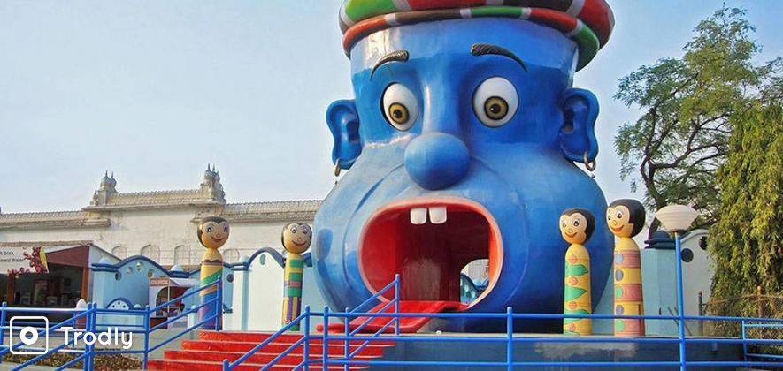**Day 2: Ramoji film city**

Ramoji Film City, a tribute to the bewitching magic of cinema, is the dream destination for entertainment and relaxation. Millions of tourists from all over the world come to the complex every month to revel in its infinite leisure and recreation options. Spread over idyllic 2,500 acres and studded with hills, woods, and lakes and striking architectural triumphs, Ramoji Film City is one of Asia's fastest growing tourism destinations. Overnight stay at hotel.

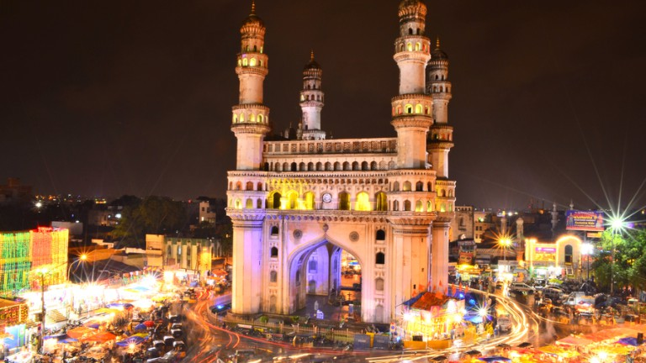**Day 3: Hyderabad sightseeing**

After the breakfast, proceed to visit one of the famous forts of India. The name originates from the Telugu words "**Golla Konda**" meaning "Shepherd's Hill". Then visit **Charminar**, is as much the signature of Hyderabad. Charminar has 45 prayer spaces and a mosque in it. Visitors can view the architectural splendour inside the Charminar. Then proceed to **Mecca Masjid** A two hundred yards southwest of the Charminar is the Mecca Masjid, so named because the bricks were brought from Mecca to build the central arch. **Salarjung museum** this museum houses one of the biggest one-man collections of antiques of the world by Mir Yousuf Ali Khan, **Snow World** (Sightseeing as time permits) Later transfer to hotel. Overnight stay at hotel. All major city sightseeing will be covered as time permits.

**Day 04: Hyderabad – Departure**

Morning after breakfast free to relax at the hotel.

Free for shopping or sightseeing as time permits. Later according to the flight timings transfer to airport to board flight with sweet memories of a wonderful holiday.

**Inclusions:**

* 03 nights’ accommodation
* 03 Breakfast
* A/c Innova for pick up, drop and sightseeing
* Parking charges
* **Entrance tickets**
* Guide
* GST

**Exclusions:**

* **Flight fare / Train Fare**
* Items of a personal nature such as phone calls, room services, laundries or other expenditures during the tour
* Meals not specified
* Evening Tea/Snacks on all days
* Airport / Hotel porter charges
* Use of items from Mini bar inside rooms at each hotel