.



**BHUTAN PACKAGE**

**05N/06D**

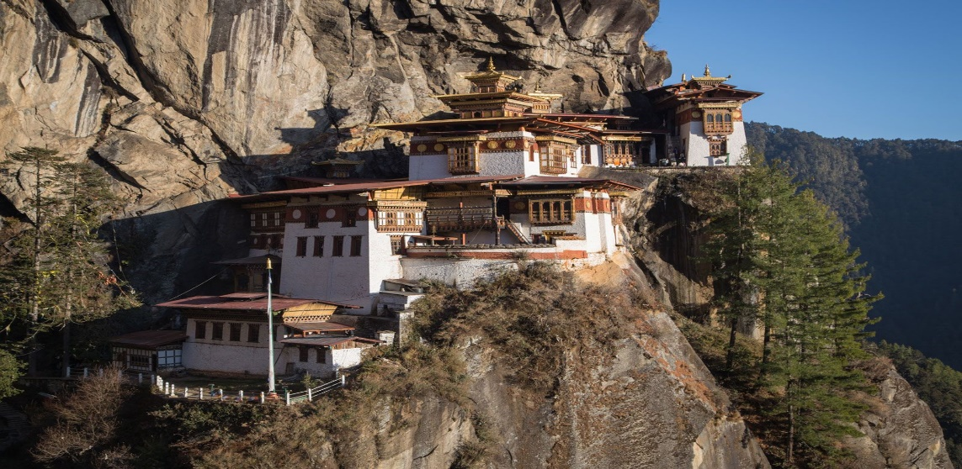

**Itinerary**

**Day 1. Paro – Thimphu:**

Driving Distance: 65 Km, Driving time: 1.5 – 2 Hr., Altitude of Thimphu: 2,350 m

Your flight to Paro on a clear day, is marked with the panoramic views of the Himalayas including the Everest and other famous Peaks. The approach through the foothills and the landing (including few steep turns) at the tiny airstrip of Paro has been termed as adventurous by many travelers. After the completion of immigration formalities at the Paro Airport exit door, you will be received by your Bhutanese guide with traditional **“Tashi Khadar”.** Afterwards drive to Thimphu following the Pa Chhu (River). Check-In to the hotel and have your first experience with Bhutanese Cuisine. Rest of the day is at leisure. You can explore the Thimphu valley and town or shop till your heart’s content. Overnight at the Hotel in Thimphu

**Day 2. Thimphu Sightseeing:**

Today you would be driven in and around Thimphu covering key places of interest. After breakfast you would visit

Ø  **Kuensel Phodrang**, the gigantic Buddha Dordenma Statue located atop a hill in Kuensel Phodrang Nature Park.

Ø  **National Memorial Chhorten**, a Stupa built in 1974 to honor the third [Druk Gyalpo](https://en.wikipedia.org/wiki/Druk_Gyalpo), [Jigme Dorji Wangchuck](https://en.wikipedia.org/wiki/Jigme_Dorji_Wangchuck). Every morning till night old people and young people circumambulate the Chhorten. **You may choose to light butter lamps and also circumambulate around the Chorten.**

Ø  **Zorig Chusum,**Premier institute of traditional arts and crafts in Thimphu established with an objective of preserving “thirteen arts and crafts of Bhutan”.

Ø  **Folk Heritage**, traditional house giving an insight to the Bhutanese lifestyle, and artifacts from the rural households

In the afternoon you would be taken to

Ø  **Sangaygang View Point,**also known as BBS Tower offering panoramic view of Thimphu Town situated at an elevation of 2,685 m.

Ø  **Changangkha Monastery**, popular fortress like temple perched on a ridge above Central Thimphu built in 15th Century by Lama Phajo Drugom Zhipo.

Ø  **Takin Preserve Centre**, see Takin (National animal of Bhutan) It is a unique combination of Goat and an Antelope

Ø  **Tashichhodzong,**or ‘the fortress of the glorious religion’. Initially erected in 1641 by Shabdrung Ngawang Namgyal, it was rebuilt in the 1960s during the reign of Bhutan’s third king in the traditional style, without plans or nails. It houses some ministries, His Majesty’s secretariat, and the central monk body and opens after 5 PM.

On the completion of sightseeing, you are driven back to your hotel. Overnight at the Hotel in Thimphu.

**Day 3. Thimphu – Punakha/ Wangdue:**

Distance: 76 Km, Driving time: 1.5 - 2 Hr, Altitude of Punakha: 1310 m

After breakfast you are driven to Punakha. On the way stop at

Ø  **Dochula Pass, l**ies at an elevation of 3,150 m and is a great place to view the higher Himalayas. The landmarks around the pass includes 108 Druk Wangyal Stupas built under the patronage of Queen Ashi Dorji Wangmo Wangchuk

Thereafter, you continue your drive to Punakha. While in Punakha you would visit

Ø  **Punakha Dzong,**built in 1637 by Shabdrung Ngawang Namgyal. For many years until the time of the second King, it served as the seat of the Government. It is still the winter residence of Je-Khenpo (The Chief Abbot of the Central Monastic Body of Bhutan)

Ø  **Chhimi Lhakhang,**a famous Temple, which is also known as “The Temple of Fertility” built by Lama Drukpa Kuenley

Ø  **Explore the Punakha and Wangdue Valley for a while**

Dinner and overnight at the Hotel in Punakha/Wangdue

**Day 4. Punakha – Paro:**

Driving Distance: 135 km, Driving Time: 4-5 Hr., Altitude of Paro: 2280 m

After breakfast, you would check out of the hotel to proceed to Paro for the final leg of the tour. On the way stop at

Ø  **Royal Botanical Park, Lamperi**, also known as the Rhododendron Garden. It is the first Botanical Garden of Bhutan. It is famous for 46 species of [rhododendron](https://en.wikipedia.org/wiki/Rhododendron)s.

Ø  **Tamchog Lhakhang**, built by Thangthong Gyalpo in the 15th Century, Thangthong Gyalpo is also known as the iron bridge Builder. The walk the suspension iron chain bridge, the feel of the soothing breeze and river could be a great experience.

After arriving at Paro, you would be transferred to you Hotel for Check In. Post lunch, you would be taken around to visit

After arriving at Paro, you would be transferred to you Hotel for Check In. Post lunch, you would be taken around to visit

Ø  **Paro Rimpung Dzong**, also known as Fortress of the heap of jewels, built during the time of Shabdrung Ngawang Namgyal in 1646

Ø  **Ta Dzong**, an ancient watch tower overlooking Rimpung Dzong built in 1951 now converted into national museum.

Evening is free for leisure activities such as Archery experience, National Dress wearing experienceon direct payment basis and shopping around the Paro Town. Dinner and overnight at the Hotel in Paro.

**Day 5. Paro Sightseeing and Hike to Taktsang:**

After breakfast, start your day with a hike to

Ø  **Taktsang Monastery (Tiger's nest),**the abode of gods and monks situated at an altitude of 3100m on the Upper Paro Valley, Bhutan. As per the legend, Guru Padmasambhana (Guru Rinpoche), the tantrum mystic who brought Buddhism to Bhutan, came in the form of Dorje Droloe riding a flying tigress to subdue the demon that was obstructing the spread of Buddhism in the Himalayas.

Post lunch, visit

Ø  **Kyichu Lhakhang**, one of the oldest monasteries in Bhutan built in the 7th century by the Tibetan Emperor Songtsen Gampo

OR a day trip to Chelela Pass

After breakfast, drive to  **Chelela Pass, the highest motorable road in Bhutan.** The views are stunning from the Chelela pass. Enjoy sometime in Chelela Pass . You may choose to do a short hike till Kila Geonpa. Drive back to Paro. Afternoon, explore Paro Valley.

Dinner and overnight at the Hotel in Paro.

**Day 6. Departure:**

Today we will bid farewell to this beautiful country and take an early flight back. We hope by now you must have made some good friends and also have taken photographs and beautiful memories of Bhutan. We certainly hope of serving you again on your next visit to this great country or the Last Shangri-La. Tashi Delek