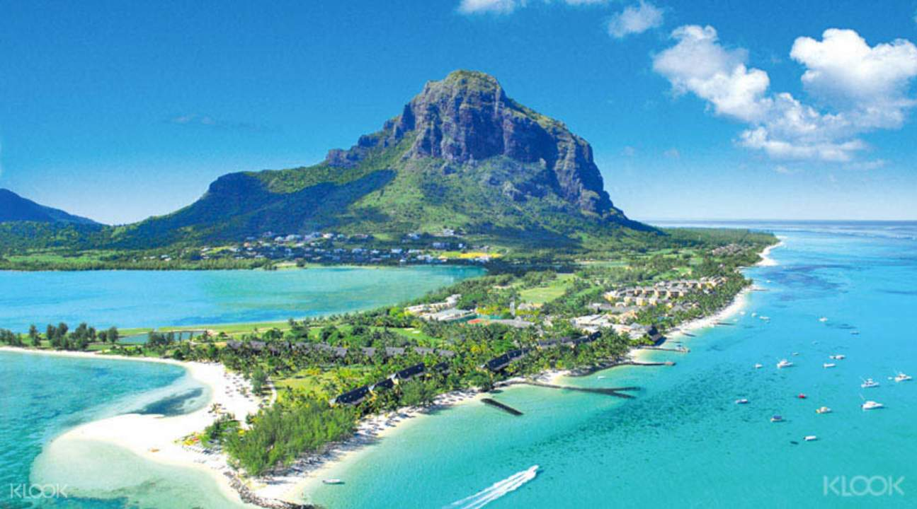

**Mauritius package**

**04 nights 05 days**

**Day 01 : Arrival at Mauritius**

Arrival at Mauritius meet our representative outside the airport, Check in at hotel. Rest of the day feel free for leisure. Overnight stay at hotel.

**Day 02 : FULL DAY ILE AUX CERFS – 08H00 TO 17H00**

Pick up from hotel

Arrive at Trou D’eau Douce and embark on a speedboat to reach Ile aux Cerfs. Spend the day exploring the island, enjoying the sandy beach and water activities such as parasailing, tube ride and undersea-walking, waterfall visit available at a supplement.

You can enjoy your lunch at the Indian Restaurant ‘Masala’ on the island (at your own cost) Pick up by speedboat at the jetty and reach the shore in approximately 30mins.

Drive back to your hotel.

**Day 03 : FULL DAY SOUTH TOUR – 09h00- 17h00**

Pick up from hotel.

Reach Floreal, well known shopping town as well as visit to ship model & Diamond factory Drive to the crater of Trou aux Cerfs, the crater of an extinct volcano for a photo stop.

Reach Grand Bassin (Ganga Talao) for a visit of the temples and the holy lake Visit of Vallee des Couleurs (entrance fees excluded), its 23 coloured earths and its spectacular Waterfalls.

Drive back to your hotel.

**Day 04 : FULL DAY NORTH TOUR – 09H00 T0 17H00**

Pick up from hotel

Arrive in Port Louis; Drive through different places of worship (Chinese Pagoda, Cathedrals)

Photo stop at La Citadelle, the best place for a panoramic view of the whole Capital City; Drive down to the race track of Champs de Mars, the 2nd oldest race track in the world Stop for shopping at the central market, the Caudan Waterfront & Bagatelle Shopping Mall – lunch at leisure

Drive back to your hotel

**Day 05 : Mauritius departure**

Morning after breakfast proceed to Mauritius airport to board the return flight.