

**Thailand package**

**04 nights and 05 days**

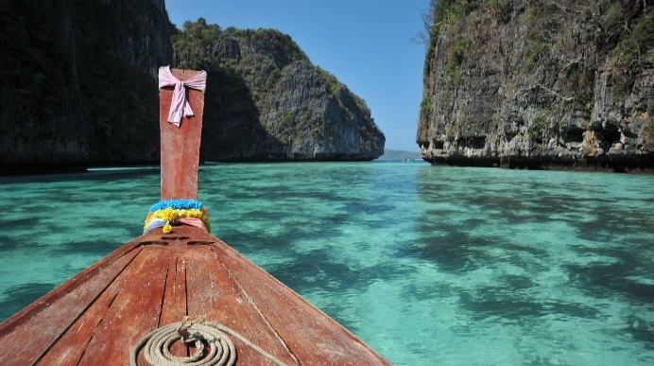 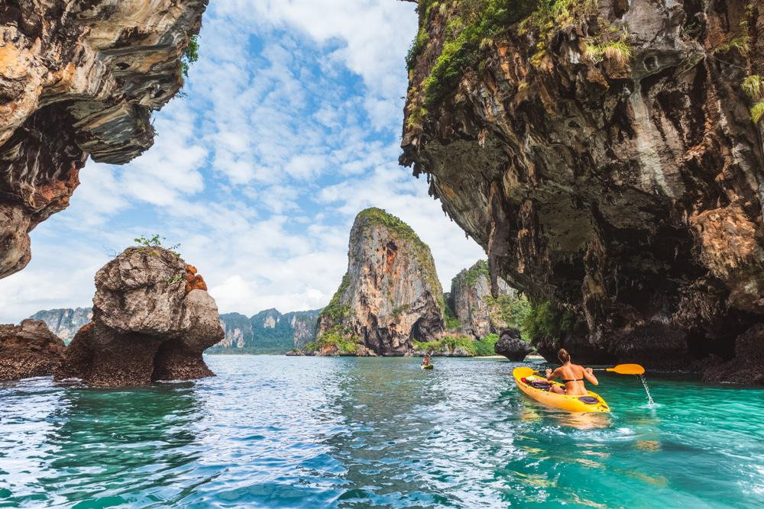

**Tentative itinerary: -**

**Day 1 - Arrival Bangkok – Pattaya (Alcazar Show in Pattaya)**

Arrive at Bangkok, after which you will be assisted with transfer to Pattaya, a 02 hour drive from Bangkok. On arrival, check-in to hotel. Evening proceed for Alcazar show.

The Alcazar Show in Pattaya is a show you must not miss. It is an evening of a world-famous cabaret in a grand theatre with 1,200 seats and a state-of-the-art light and sound system. Attend the extravagant show of unique blend of acting, stage design, costumes and glamour. Have dinner at one of the Indian and local restaurants.

Overnight stay in the hotel.

**Day 2 - Coral Island Tour in Pattaya with Lunch**

Start the day with breakfast at the hotel. Later, avail the pick-up facility to the jetty to board the speed boat for a tour to the fascinating beauty, Coral Island, also known as Koh Lann Island.

Arrive to the soft white sandy shores with a number of exciting things to do during a day-visit. Banana Boat ride will be included in the package. Rest you can enjoy a leisure walk and small shopping possible at the island. Those interested in water sports activities can do parasailing, water-skiing, jet skiing, explore the undersea world of Island by opting for deep-sea diving and snorkelling - additional water sports on extra direct payment basis.

Overnight stay in Pattaya.

**Day 3 - Bangkok – City and Temple tour**

Start the day with breakfast at the hotel. Get ready and leave for a city and temple tour of Bangkok. The Buddhist temples are locally known as WATS. On your tour, first visit the Wat Traimit, Temple of the Golden Buddha which is home to a 5.5 ton statue of the holy Buddha made from solid gold and is a fine example of Sukhothai art. Next, pay a visit to Wat Pho, Temple of the Reclining Buddha, home to the largest and also the oldest shrine of its kind in Bangkok. Later, proceed for a shopping spree at the Gems Gallery.

After a well-spent day get back to the comfort of your hotel. Later free for leisure.

Overnight stay in Bangkok.

**Day 4 - Bangkok (Safari World and Marine Park)**

Have a leisurely breakfast at hotel. Visit the Safari World and Marine Park. Thailand's popular open zoo is divided into four distinct sections - Safari Park, Bird Park, Games Corner and Macaw Island. Spend time viewing dolphins, orangutans, seals and a myriad of other exotic animals and birds in a scenic African setting. Return to the hotel or you can continue with your exploration. Overnight stay in the hotel.

**Day 5 - Tour ends**

Today is the last day of your tour. Post breakfast, check out from the hotel. Avail the timely transfer to the Bangkok International Airport for your return flight. Return home with cherished memories of holiday in Thailand.