

**Baku package**

**05 Nights 06 Days**

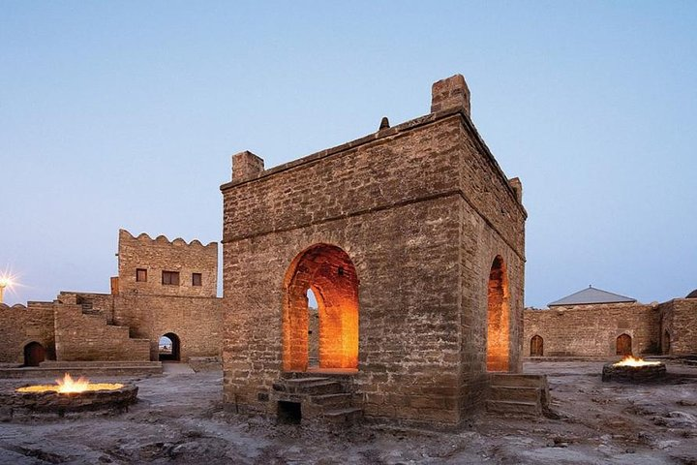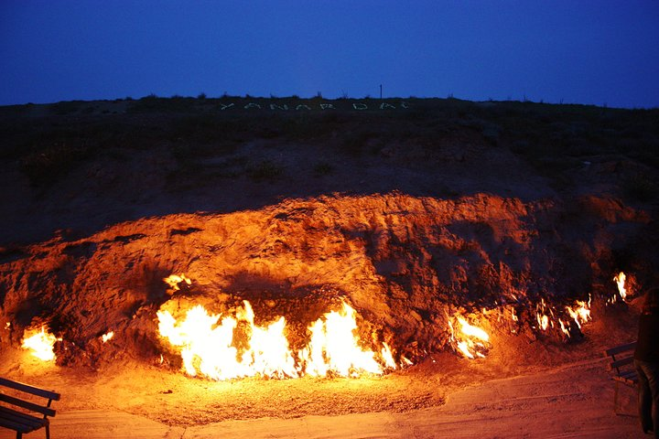

**Day 1 – Transfer from airport to hotel / Free day. Overnight in Baku**

On arrival at Baku after all formalities at airport meet and greet our representative outside the airport then proceed to hotel, Check in at hotel. Evening panoramic tour Visiting Avenue of martyrs Exploring Highland park and Walking excursion through Nizami street. Overnight stay at hotel.

**Day 2 – Baku city Tour**

Morning after breakfast cover all the must-see stops in history-packed Baku on this time-saver tour of the Azerbaijani capital Seaside Boulevard, Palace of Happiness, Maiden Tower etc. Overnight stay at hotel.

**Day 3 – Gabala Tour. Overnight in Baku**

Morning after breakfast get out of the city and explore the nature of Azerbaijan on this private tour. Depart from your Baku hotel in a car with a driver and make your way towards Gabala. Visit Diri Baba Mausoleum and Shamakhi Juma Mosque. Ride in a historic Lada car to the Seven Beauties Waterfall. Head to Nohur Lake and take a boat trip. Over night stay at Baku hotel.

**Day 4 – Absheron fire tour. Overnight in Baku**

Absheron is located 25 km from Baku. Ateshgah temple and Burning Mountain included to Absheron tour.

**1.Fire temple -Ateshgah**Ateshgah (from [Persian](https://en.wikipedia.org/wiki/Persian_language): آتشگاه‎, *Atashgāh*, [Azerbaijani](https://en.wikipedia.org/wiki/Azerbaijani_language): *Atəşgah*), often called the “Fire Temple of Baku” is a castle-like religious temple in [Surakhani town](https://en.wikipedia.org/wiki/Suraxan%C4%B1_(town)) (in [Suraxanı raion](https://en.wikipedia.org/wiki/Suraxan%C4%B1_raion))a suburb in [Baku](https://en.wikipedia.org/wiki/Baku), [Azerbaijan](https://en.wikipedia.org/wiki/Azerbaijan).Based on Persian and Indian inscriptions, the temple was used as a [Hindu](https://en.wikipedia.org/wiki/Hindu), [Sikh](https://en.wikipedia.org/wiki/Sikh), and [Zoroastrian](https://en.wikipedia.org/wiki/Zoroastrianism) place of worship. “Atash” (آتش) is the Persian word for fireThe pentagonal complex, which has a courtyard surrounded by cells for monks and a tetrapillar-altar in the middle, was built during the 17th and 18th centuries. It was abandoned in the late 19th century, probably due to the dwindling of the Indian population in the area.

Burning mountain- Yanar Dag ([Azerbaijani](https://en.wikipedia.org/wiki/Azerbaijani_language): *Yanar Dağ*, meaning “burning mountain”) is a [natural gas](https://en.wikipedia.org/wiki/Natural_gas) fire which blazes continuously on a hillside on the [Absheron Peninsula](https://en.wikipedia.org/wiki/Absheron_Peninsula) on the [Caspian Sea](https://en.wikipedia.org/wiki/Caspian_Sea) near [Baku](https://en.wikipedia.org/wiki/Baku), the capital of [Azerbaijan](https://en.wikipedia.org/wiki/Azerbaijan) (a country which itself is known as “[the Land of Fire](https://en.wikipedia.org/wiki/The_Land_of_Fire)“). Flames jet into the air 3 metres (9.8 ft) from a thin, porous sandstone layer.

**2.Burning mountain- Yanar Dag** ([Azerbaijani](https://en.wikipedia.org/wiki/Azerbaijani_language): *Yanar Dağ*, meaning “burning mountain”) is a [natural gas](https://en.wikipedia.org/wiki/Natural_gas) fire which blazes continuously on a hillside on the [Absheron Peninsula](https://en.wikipedia.org/wiki/Absheron_Peninsula) on the [Caspian Sea](https://en.wikipedia.org/wiki/Caspian_Sea) near [Baku](https://en.wikipedia.org/wiki/Baku), the capital of [Azerbaijan](https://en.wikipedia.org/wiki/Azerbaijan) (a country which itself is known as “[the Land of Fire](https://en.wikipedia.org/wiki/The_Land_of_Fire)“). Flames jet into the air 3 metres (9.8 ft) from a thin, porous sandstone layer

Overnight at Baku hotel.

**Day 5 – Gobustan tour + Mud volcano Overnight in Baku**

Morning after breakfast Visit the same-name interactive museum where the guests get information about animal and vegetal life of Gobustan with the help of special multimedia. Studying pre-historic petroglyphs, inscriptions and pictograms at the Boyukdash Mount dating back to 10,000 BC, Transfer to Mud volcanoes and Transfer to hotel over Night at hotel

**Day 6 – Transfer from hotel to airport**

Morning after breakfast proceed to Baku airport to board the departure flight. Overnight stay at hotel.