

**Nainital - Jim Corbett**

**03n/04d**

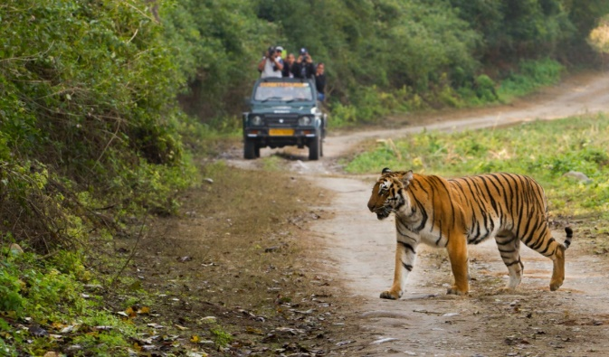

**Itinerary: -**

**Day 1 - Delhi – Nainital (323 km/7 hours)**

On arrival at Delhi airport our representative will meet and greet you and then, hit the road to Nainital. A picturesque hill station in Uttarakhand, Nainital is blessed with oodles of natural wonders. Perched at the height of 6,358 feet above sea level, the hill town lures tourists from different nooks and corners of the globe. The place is also quite popular among the honeymooners.

Upon arrival, check-in at the hotel. Then, spend the rest of the day relaxing. But, if you want, you can also explore the attractions nearby. Or else, you can walk to Mall Road. Enjoying a boat ride on the Naini Lake is also an option at an additional cost.

Overnight stay at the hotel.

**Day 2 - Nainital**

After delicious breakfast, you can begin sightseeing the attractions in and around Nainital. Rejuvenate your senses with the ethereal charm of the verdant jungles, lush valleys, soft white clouds, stunning vistas and so much more. Finally, pay homage at the Hanumangarhi Temple. Dedicated to Lord Hanuman, the sacred shrines offer astounding sunrise and sunset views.

Next, you can calm your senses at the popular lakes in Nainital. Take a tour of Bhimtal, Sattal and Naukuchiatal. A beautiful gem of Nainital, the Bhimtal is adorned with a cerulean lake and temples nestled amid the green mountains. Sattal, on the other hand, is an interconnected group of seven freshwater lakes. Tucked beautifully amidst hills, Naukuchiatal, the lake of nine corners, is truly surreal. Don't forget to delight in boat rides here.

Overnight stay at the hotel.

**Day 3 - Nainital – Corbett (64 km/2 hours) - Nainital**

With a hearty breakfast. Thereafter, you will check out from the hotel and get ready for your trip to Jim Corbett. Nestled in Nainital, Jim Corbett National Park was established in 1936. Reckoned as the first national park in the Asian continent, it is home to a variety of flora and fauna, including endangered species and Royal Bengal Tigers. The oldest national park in India derived its name from a hunter turned conservationist Edward James Corbett (Jim Corbett). It was the very place where Project Tiger was launched in 1973. Presently, Corbett is divided into five different zones where visitors can delight in wildlife safaris.

Upon reaching, check-in at the hotel. Unwind yourself and proceed for an evening safari in the park, which can be arranged at an additional cost. Enjoy spotting various species of flora and fauna. The rest of the day is to be spent leisurely.

Return back to Nainital.

Overnight stay at the hotel.

**Day 4 - Nainital - Delhi (323 km/7 hours)**

After breakfast return back to Delhi. After reaching, get comfortably transferred to the Delhi Airport or Railway Station for your onward journey.

………………………………………………..