

**05 NIGHTS/06 DAYS**

**KASHMIR PACKAGE**

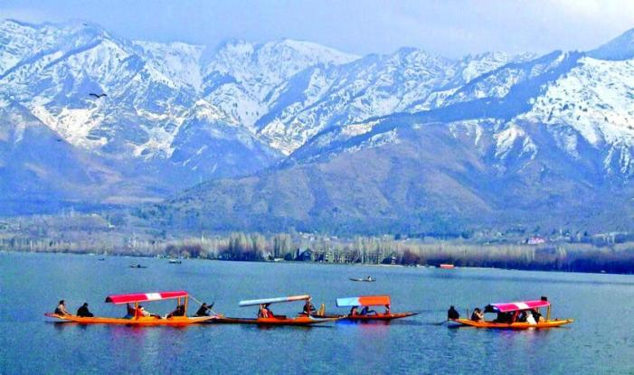

**Tentative itinerary: -**

**Day 01- Arrive Srinagar – Local sightseeing**

On arrival at Srinagar. Our representative will heartily greet you and assists you from airport. Check in at hotel – evening proceed for local sightseeing and Shikara ride.

Overnight stay at Srinagar hotel.

**Day 02 - Srinagar to Gulmarg (60 Kms / 2 Hrs approx.)**

Morning after breakfast proceed for a scenic drive to Gulmarg. Gulmarg (Meadow of

Gold). Gulmarg was discovered as a tourist destination by the British in the 19th century.

Prior to that, Mughal emperors vacationed in the Gulmarg valley which is about 03 kms

long and up-to 01 km wide. Gulmarg has one of the best Ski slopes in the world and

highest golf course of the world with 18 holes. (Gondola ride can be done)

Overnight stay at Gulmarg hotel.

**Day 03 – Gulmarg - Pahalgam (80 Kms / 03 Hrs approx.)**

Morning after breakfast proceed to Pahalgam - Pahalgam **(Valley of Shepherds).**

Overnight stay at Pahalgam hotel.

**Day 04 – Pahalgam – Srinagar**

After breakfast proceed check out from Pahalgam hotel and proceed to Srinagar. On the way visit world famous **Betaab vallay, Aru Vallay and Chandanwari,** which are the most scenic and serene spots in Pahalgam, all these can be covered by local taxi or by horse riding (on direct payment basis).

Overnight stay at Srinagar hotel.

**Day 05 – Day trip to Sonmarg (80 Kms / 03 Hrs approx.)**

After breakfast leave for Sonmarg (Meadow of Gold ) which is about 80 kms from Srinagar City in the Ganderbal District, It is one of the most visited, scenic, serene  place in Kashmir, mostly visited for Seeing Snow even in Summer, enjoy full day fun there, you can ride a pony to see the **Thajwas Glacier** covered with ice, **Zero Point (Snow Point**) located around **Zojila pass** near to Kargil  **(Need to hire a local union shared taxi to cover these both points on direct payment basis (negotiable charges),** Late evening drive back to Srinagar.

Overnight stay at Srinagar hotel.

**Day 06 - Srinagar Departure**

After breakfast you will be transferred to airport for onward destination.

Tour and Services ends with sweet memories